**Bank Loan Report**

**SQL Query Document**

**Total Loan Applications**

SELECT COUNT(id) AS Total_Applications FROM bank_loan_data



**MTD Loan Applications**

SELECT COUNT(id) AS Total_Applications FROM bank_loan_data

WHERE MONTH(issue_date) = 12



**PMTD Loan Applications**  
SELECT COUNT(id) AS Total_Applications FROM bank_loan_data

WHERE MONTH(issue_date) = 11



**Total Funded Amount**

SELECT SUM(loan_amount) AS Total_Funded_Amount FROM bank_loan_data



**MTD Total Funded Amount**

SELECT SUM(loan_amount) AS Total_Funded_Amount FROM bank_loan_data

WHERE MONTH(issue_date) = 12



**PMTD Total Funded Amount**

SELECT SUM(loan_amount) AS Total_Funded_Amount FROM bank_loan_data

WHERE MONTH(issue_date) = 11



**Total Amount Received**

SELECT SUM(total_payment) AS Total_Amount_Collected FROM bank_loan_data



**MTD Total Amount Received**

SELECT SUM(total_payment) AS Total_Amount_Collected FROM bank_loan_data

WHERE MONTH(issue_date) = 12



**PMTD Total Amount Received**

SELECT SUM(total_payment) AS Total_Amount_Collected FROM bank_loan_data

WHERE MONTH(issue_date) = 11



**Average Interest Rate**

SELECT AVG(int_rate)*100 AS Avg_Int_Rate FROM bank_loan_data



**MTD Average Interest**

SELECT AVG(int_rate)*100 AS MTD_Avg_Int_Rate FROM bank_loan_data

WHERE MONTH(issue_date) = 12



**PMTD Average Interest**

SELECT AVG(int_rate)*100 AS PMTD_Avg_Int_Rate FROM bank_loan_data

WHERE MONTH(issue_date) = 11



**Avg DTI**

SELECT AVG(dti)*100 AS Avg_DTI FROM bank_loan_data



**MTD Avg DTI**

SELECT AVG(dti)*100 AS MTD_Avg_DTI FROM bank_loan_data

WHERE MONTH(issue_date) = 12



**PMTD Avg DTI**

SELECT AVG(dti)*100 AS PMTD_Avg_DTI FROM bank_loan_data

WHERE MONTH(issue_date) = 11



**GOOD LOAN ISSUED**

**Good Loan Percentage**

SELECT

(COUNT(CASE WHEN loan_status = 'Fully Paid' OR loan_status = 'Current' THEN id END) * 100.0) /

COUNT(id) AS Good_Loan_Percentage

FROM bank_loan_data



**Good Loan Applications**

SELECT COUNT(id) AS Good_Loan_Applications FROM bank_loan_data

WHERE loan_status = 'Fully Paid' OR loan_status = 'Current'



**Good Loan Funded Amount**

SELECT SUM(loan_amount) AS Good_Loan_Funded_amount FROM bank_loan_data

WHERE loan_status = 'Fully Paid' OR loan_status = 'Current'



**Good Loan Amount Received**

SELECT SUM(total_payment) AS Good_Loan_amount_received FROM bank_loan_data

WHERE loan_status = 'Fully Paid' OR loan_status = 'Current'



**Bad Loan Issued**

**Bad Loan Percentage**

SELECT

(COUNT(CASE WHEN loan_status = 'Charged Off' THEN id END) * 100.0) /

COUNT(id) AS Bad_Loan_Percentage

FROM bank_loan_data



**Bad Loan Applications**

SELECT COUNT(id) AS Bad_Loan_Applications FROM bank_loan_data

WHERE loan_status = 'Charged Off'



**Bad Loan Funded Amount**

SELECT SUM(loan_amount) AS Bad_Loan_Funded_amount FROM bank_loan_data

WHERE loan_status = 'Charged Off'



**Bad Loan Amount Received**

SELECT SUM(total_payment) AS Bad_Loan_amount_received FROM bank_loan_data

WHERE loan_status = 'Charged Off'



**Loan Status**

SELECT

loan_status,

COUNT(id) AS LoanCount,

SUM(total_payment) AS Total_Amount_Received,

SUM(loan_amount) AS Total_Funded_Amount,

AVG(int_rate * 100) AS Interest_Rate,

AVG(dti * 100) AS DTI

FROM

bank_loan_data

GROUP BY

loan_status

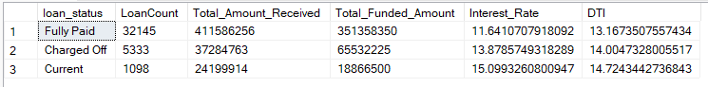

SELECT

loan_status,

SUM(total_payment) AS MTD_Total_Amount_Received,

SUM(loan_amount) AS MTD_Total_Funded_Amount

FROM bank_loan_data

WHERE MONTH(issue_date) = 12

GROUP BY loan_status

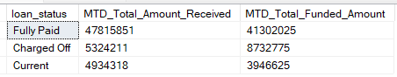

**Overview Dashboard**

**Month**

SELECT

MONTH(issue_date) AS Month_Munber,

DATENAME(MONTH, issue_date) AS Month_name,

COUNT(id) AS Total_Loan_Applications,

SUM(loan_amount) AS Total_Funded_Amount,

SUM(total_payment) AS Total_Amount_Received

FROM bank_loan_data

GROUP BY MONTH(issue_date), DATENAME(MONTH, issue_date)

ORDER BY MONTH(issue_date)

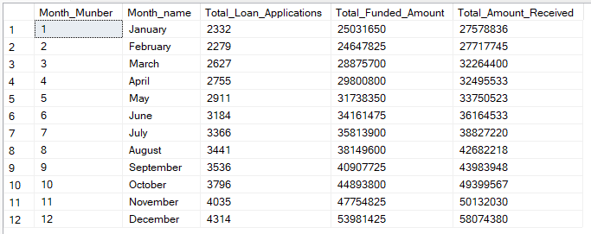

**State**

SELECT

address_state AS State,

COUNT(id) AS Total_Loan_Applications,

SUM(loan_amount) AS Total_Funded_Amount,

SUM(total_payment) AS Total_Amount_Received

FROM bank_loan_data

GROUP BY address_state

ORDER BY address_state

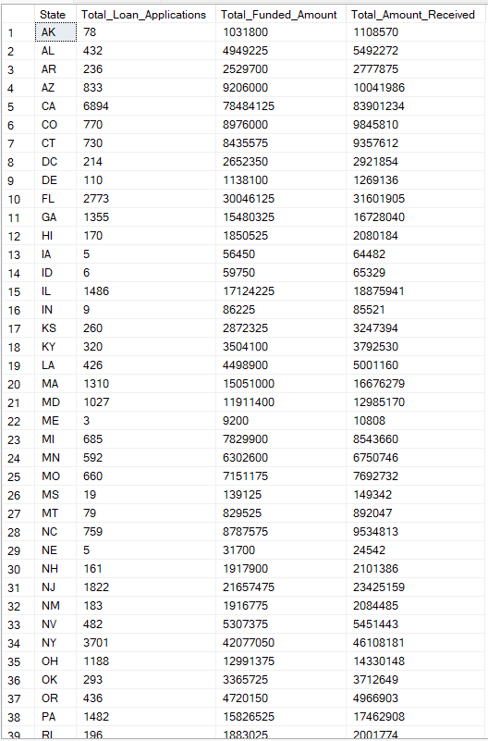

**Term**

SELECT

term AS Term,

COUNT(id) AS Total_Loan_Applications,

SUM(loan_amount) AS Total_Funded_Amount,

SUM(total_payment) AS Total_Amount_Received

FROM bank_loan_data

GROUP BY term

ORDER BY term

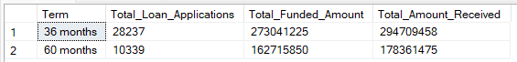

**Employee Length**

SELECT

emp_length AS Employee_Length,

COUNT(id) AS Total_Loan_Applications,

SUM(loan_amount) AS Total_Funded_Amount,

SUM(total_payment) AS Total_Amount_Received

FROM bank_loan_data

GROUP BY emp_length

ORDER BY emp_length

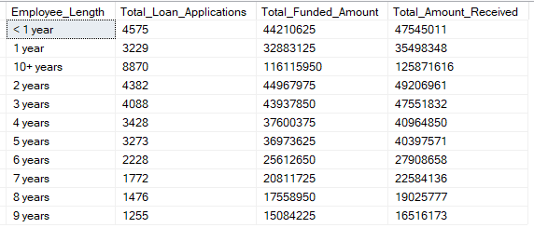

**Purpose**

SELECT

purpose AS PURPOSE,

COUNT(id) AS Total_Loan_Applications,

SUM(loan_amount) AS Total_Funded_Amount,

SUM(total_payment) AS Total_Amount_Received

FROM bank_loan_data

GROUP BY purpose

ORDER BY purpose

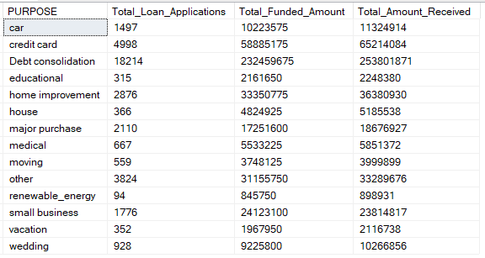

**Home Ownership**

SELECT

home_ownership AS Home_Ownership,

COUNT(id) AS Total_Loan_Applications,

SUM(loan_amount) AS Total_Funded_Amount,

SUM(total_payment) AS Total_Amount_Received

FROM bank_loan_data

GROUP BY home_ownership

ORDER BY home_ownership

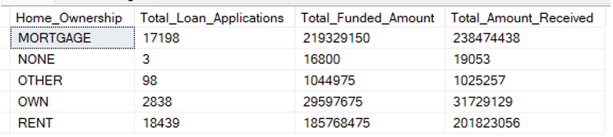

Note: We have applied multiple Filters on all the dashboards. You can check the results for the filters as well by modifying the query and comparing the results.

For e.g

See the results when we hit the Grade A in the filters for dashboards.

*SELECT*

*purpose AS PURPOSE,*

*COUNT(id) AS Total_Loan_Applications,*

*SUM(loan_amount) AS Total_Funded_Amount,*

*SUM(total_payment) AS Total_Amount_Received*

*FROM bank_loan_data*

*WHERE grade = 'A'*

*GROUP BY purpose*

*ORDER BY purpose*